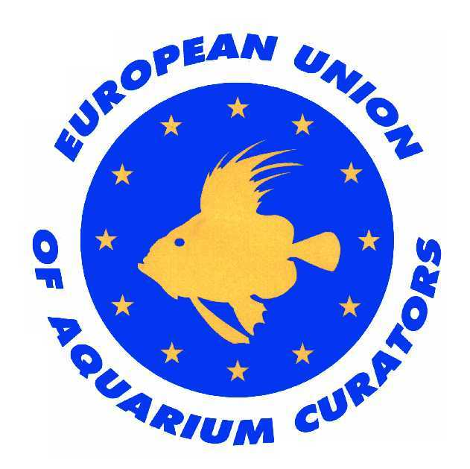APPLICATION FORM FOR EUAC MEMBERSHIP.

The undersigned :

Name:
Institution:
Address:
Zip code and city:
Country:
Tel. / Fax:
e-mail:
is applying for personal membership to the European Union of Aquarium Curators.
(Category to be decided by the executive board).

My position at the institute is: (describe your function in a maximum of 15 lines):

I have a degree in :

I have years of experience in Aquariology

I will act in accordance with the code of ethics laid down by the E.U.A.C.
and I agree with the general membership criteria (see attached text)

My candidature is supported by 3 full members to E.U.A.C:

- Name and Institute :
- Name and Institute :
- Name and Institute :

(These 3 members will guide the candidate through the first two years of probation)

I join my C.V. to this application form.
If your institution is not yet a member (any category) please add documentation on your aquarium.
I will make a formal presentation of my experience or new institution during my probationary period (2 years).

Date: Signature:

Mail to: isabel.koch@wilhelma.de

Code of ethics

- The aquarium must always act in the best interest of nature conservation and of animal protection.

- The aquarium shall always act in strict accordance with the laws and all regulations (e.g regarding trade of plants, animals and their derivatives i.e. CITES, EU regulations et al).

- The aquarium should not exhibit in its collections animals which are known cannot be kept for a reasonable length of time.

- The aquarium will initiate and actively support educational endeavours within its premises as far as its possibilities allow.

- The aquarium will welcome and support scientific research within its premises as far as it’s possibilities allow.

- The aquarium will contribute to a free and open flow of information and is willing to communicate with fellow members of E.U.A.C. openly and without restrictions, and give them free and open access to their premises.

- The aquarium should be prepared on a non-commercial basis to assist fellow institutions.

- The aquarium will participate in breeding efforts and E.U.A.C. professional improvement projects (e.g. FAITAG) wherever possible.

- The aquarium must not trade in souvenirs containing species or parts of species considered to be at risk.

General membership criteria

- membership will be reconsidered in case of contravention of any ethical or membership criterion.

- The membership of E.U.A.C. is not to be commercially exploited *.
- (in the case of supporting members: - to read ‘not to be commercially abused’).

- the members should always communicate with their fellow members openly and without reservation and provide assistance when necessary.

- Fellow members are always welcome to visit the aquarium and its technical installations.

